Redirect based on the Geo Location

- Pinkvilla web server is hosted on AWS, and all pages are delivered via CloudFront.
- We've enabled the CloudFront-Viewer-Country header, which allows us to identify the user's country.
- With this setup, we can now programmatically control the page behavior based on the user's geographic location,
- enabling country-specific experiences or content customization.
Note: We are not storing any user data, based on the CloudFront-Viewer-Country value behaviour of the site changes
Country-Based Content Delivery Workflow using AWS CloudFront

User Request
- A user visits a page on pinkvilla.com from any country (e.g., India, US, UK).
CloudFront CDN
- The request first hits the AWS CloudFront edge location closest to the user.
- CloudFront appends the CloudFront-Viewer-Country header (e.g., IN, US, GB).
Forward Request to Origin
- The request is forwarded to our origin server (Pinkvilla's web server hosted on EC2 or behind ALB).
- The CloudFront-Viewer-Country header is included in the request headers.
Backend Logic (Web Server)
- The application logic reads the CloudFront-Viewer-Country header.
- Based on the country code, it:
  - Loads localized content (language or offers),
  - Redirects to a country-specific subdomain/path,
  - Modifies UI/UX components,
  - Or logs analytics for country-wise tracking.
  - Source resides at : public/redirect_countrybased.php
Dynamic or Cached Response
- If the content is dynamic or country-specific, CloudFront can be configured to cache based on header values (via Cache Policies).
- Otherwise, the response is returned from cache (if available).
Page Rendered
- The user receives the personalized or country-specific page.

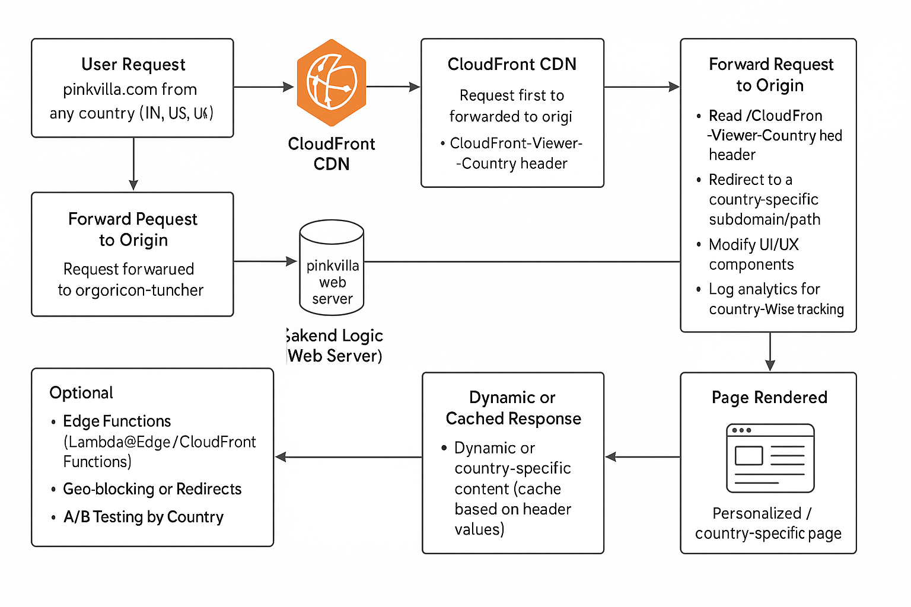
Implementation on Development Version
We have implemented two cases
1) Website is blocked for the countries US,UK,CA
2) Google Analytic( Tracking ) is blocked for the country FR
To check visit https://english.xynie.com/ for the following countries

